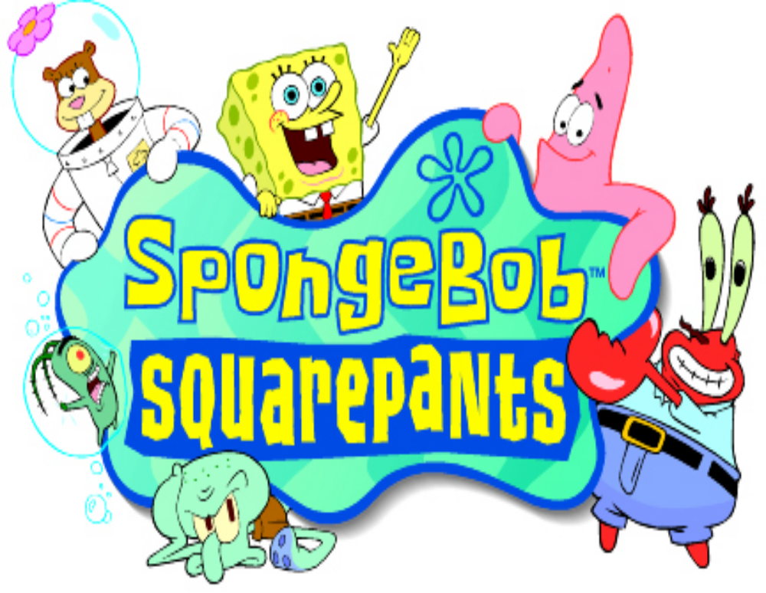User Interface
V1.2

Contents
User Interface 1
Contents 2
Document History 3
Front End 4
Front End Flow 4
Menus 5
Main Menu 5
Load Game Menu 5
Choosing a Memory Slot (PlayStation Only) 6
Entering a Password (GAME BOY Only) 10
Options Menu 12
Credits 12
Bonus Movies (PlayStation Only) 12
Map Screen 13
Map Screen Navigation 13
Kelp World 14
Level Complete 14
Score Rating 14
Kelp World Ticket 16
Losing Lives & Game Over 16
Winning The Game 16
Cheats 17
Game Controls 18
Game Controls 18
Overview 18
Movement 18
Actions 18
Using Items 19
Menus & Speech Bubbles 19
PlayStation 20
GAME BOY Advance 20
Control Summary 21
Game Information 22
Health Meter 22
Water Meter 22
Ammo Counter 22
Pause Menu 23
Pickups 24
Speech bubbles 24

Document History

Version | Date | Author | Notes
1.0 | 20/11/00 | MD | Document Created
1.0 | 30/11/00 | MD | Password & Map Screen Revisions
1.1 | 08/01/01 | MD | Revisions Following Conference Call of 05/01/01
1.2 | 07/02/01 | MD | Revisions to Kelp World

Authors:

MD | Mark Davies (Climax)

Front End

Front End Flow

The game follows the standard game procedures starting with copyright notices and company logos before prompting the user for their language choice – the default being English.

The title FMA is then played – unless interrupted by the player pressing start it will eventually reach the Main Menu. Unless the player presses start before 20 seconds has surpassed a rolling demo will begin to play.

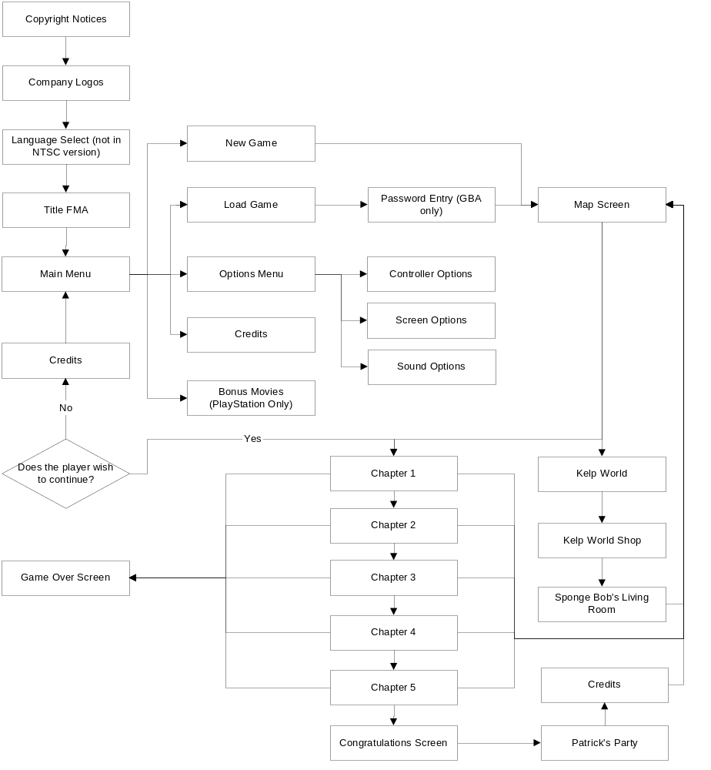

Menus

All menus operate with a simple up and down cursor and highlighted sentence. The D-Pad controls this up and down movement, and the use of start or the action button will select a menu item. The jump button can be used as a cancel button to go back one level if the player chose the wrong menu item.

Main Menu

The Main Menu has five choices for the player: New Game, Load Game, Options, Credits and Bonus Movies.

New Game will enable start the game from the very first chapter. On the PlayStation version the player will be prompted to choose a file on the memory card where the game data may be saved.

Load Game will take the player to the Load Game menu.

Options will move the player to the Options menu.

Credits will allow the player to view the production credits for the game.

Bonus Movies will allow the player to view a series of movies for forthcoming Nickelodeon releases (PlayStation only).

Load Game Menu

Due to differences in the two target platforms, the start game menu differs slightly between the two game formats.

PlayStation:
The PlayStation version makes use of the memory card, and takes up only one memory slot. Up to three separate games can be saved in this slot, allowing up to three players to save their progress.

GAME BOY Advance:
The GAME BOY version requires the player to enter passwords, as there is no memory feature available with cartridge. A screen is presented to the player, asking them to either ‘Start New Game’ or ‘Enter Password’. Starting a new game will take the player to the map screen with only the first level available to them. Entering a password requires them to enter a string of special characters. The player is then transported to the map screen where the level unlocked by the passwords and any preceding levels will be unlocked.

Choosing a Memory Slot (PlayStation Only)

The player is greeted with a simple screen that has 3 large picture squares that display an icon of their current location in the game. A cursor surrounds the currently selected game, and can be moved left and right with the D-Pad. Pressing the action button will load the game and take the player to the Map Screen. If this is the player’s first game then the picture will indicate that it is a blank slot, all level information will be saved to this new slot. If there are no spare memory slots the player will be notified that they will not be able to save the game.

Level Icons:

Chapter 1:  Chapter 2:  Chapter 3:  Chapter 4:  Chapter 5:  Kelp World:
  Jellyfish Fields | 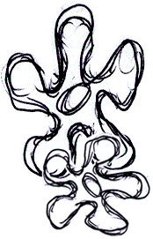
  Fish Hooks Park | 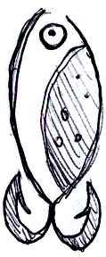
  Mother Jelly fish | 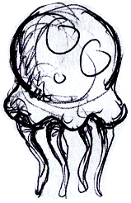
  Cavernous Canyons | 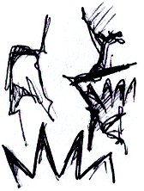
  Acrid Air Pockets | 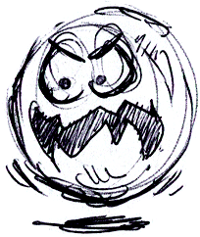
  Robotic Sub Shark | 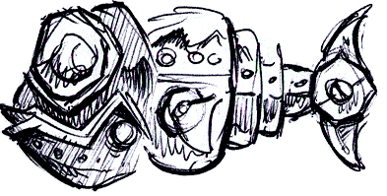
  Chum Bucket | 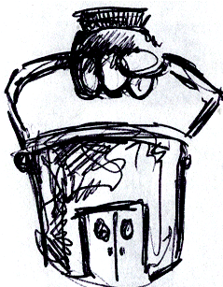
  Desert Wasteland | 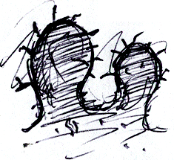
  Inside The Whale | 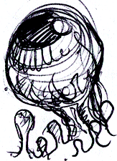
  Road to Rock Bottom | 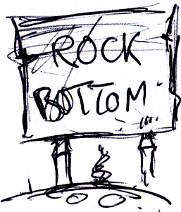
  Graveyard | 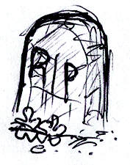
  The Flying Dutchman | 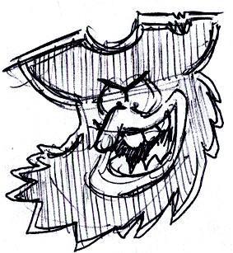
  Jelly Fields (Industrial) | 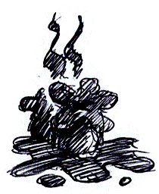
  Oil Rig | 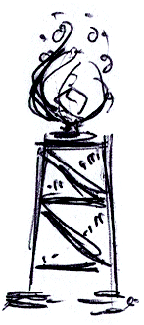
  The Iron Dogfish | 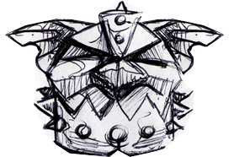
  Snail Race | 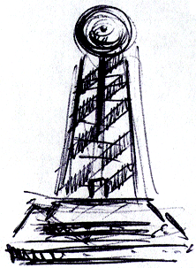
  Roller Coaster | 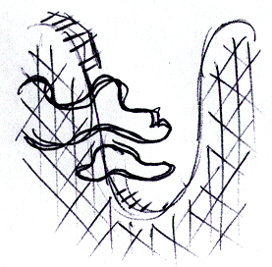
  Tunnel Of Love | 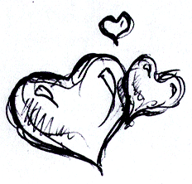
  Sandy’s Bio Dome | 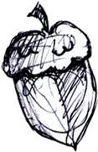
  Bikini Bottom Town | 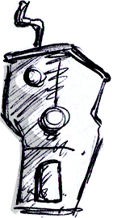
  Thermal Tunnels | 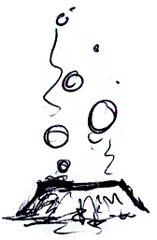
  Lava Fields | 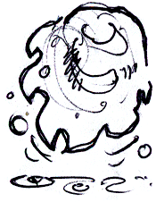
  Precipice canyon | 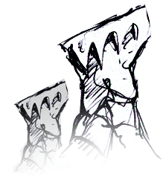
  Kelp Jungle | 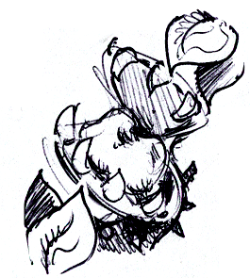
  Parasitic Worm | 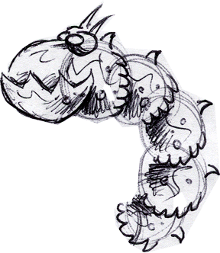
  Lonely Souls | 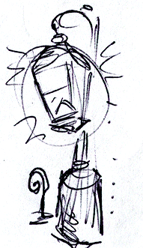
  Last Stop | 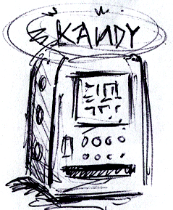
  Polluted Seabed | 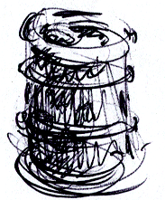
  Tuna Canning Ship | 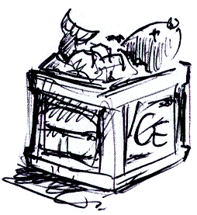
  Big Wheel | 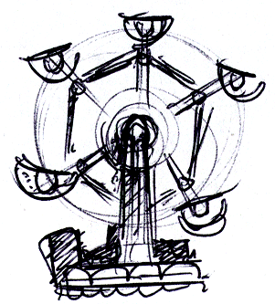
  Ghost Train | 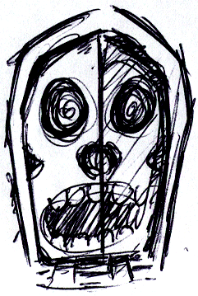

Entering a Password (GAME BOY Only)

If the player wishes to load a game on the GAME BOY, they must enter a password for the appropriate level. The password system is a 6-character string made up from eight different icons. These icons are distinctive pictures in different colors that make memorizing the passwords easy. The eight icons are: a glove balloon, a kelp bar, a bubble wand, a net, a jellyfish, a patty burger, a golden spatula and a pair of glasses.

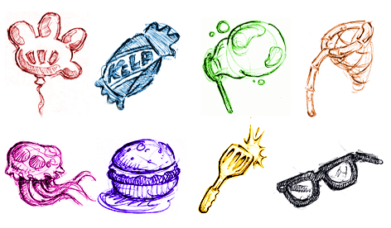

A password is entered on a special screen where there are six blank spaces. To the side is a cursor and an imaginary wheel with all the icons along it. Only three icons are displayed at a time, however the ‘wheel’ scrolls up and down by use of the D-pad.

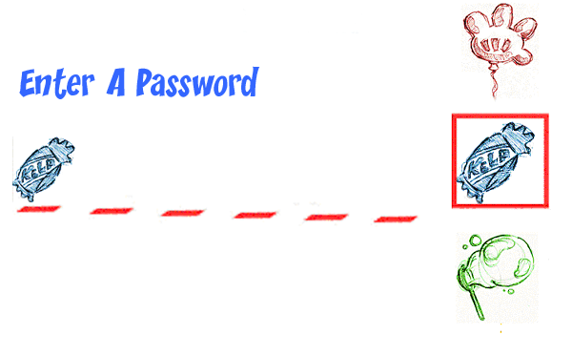

The D-pad is also used to move the cursor on the password line. The action button will insert the currently selected icon into the current cursor position. Once the icon has been entered the cursor will automatically shift one place to the right. Once the final square has been filled, the password will be checked. If it is incorrect then an error message will inform the player that they need to enter the right code – the password they entered is left intact so that they can move to the appropriate place and quickly change the icons. Otherwise they are taken to the appropriate place on the map screen.

The jump button is used to go back to the main menu screen.

Options Menu

There are a few options open to the player on both formats: Control Options, Screen Options and Sound Options.

Control Options:
Here the player can change the set up of the controller – i.e. which buttons the action and jump functions are assigned to. This is achieved via a set of predefined layouts, the player pushes left or right to choose the layout they want, and then presses start when they are happy. There will be only two layouts for the GAME BOY as there are only two buttons available (aside from the shoulder buttons) – the PlayStation has four layouts available.

Screen Options (PlayStation Only):
This menu allows the player to adjust the screen to suit their needs – this allows them to position the playfield to their liking. Two sliders control horizontal and vertical movement. The player selects the appropriate slider and then moves the D-Pad left or right from a center point.

Sound Options:
Here the player can set up the sound parameters of the game to their liking. Sliding bars indicate the level of the Music Volume, Speech Volume (PlayStation only) and the SFX Volume. These volumes are adjusted with ease by selecting the appropriate bar and moving the D-Pad left and right.

Credits

The credits display a list of all the people that were involved with the project, as well as giving thanks to those that lent their help and support. The credits are presented in a cartoon style, and (time permitting) feature a SpongeBob style caricature of the key members of the development team / publishers.

Bonus Movies (PlayStation Only)

This menu item allows the player to view a number of demo movies for upcoming Nickelodeon titles.

Map Screen

Once a game has been selected, either through the memory card, via a password or by starting a new game – the player will now arrive at the map screen.

Map Screen Navigation

Each of the five locations are displayed on the large scrolling map, as well as the bonus levels of Kelp World. A line links the five main chapters, and shows the route SB will have to travel. Within each location are five areas that the player must explore (four levels and one boss). SpongeBob can walk along this large map from area to area by pressing the appropriate direction on the D-Pad, however he cannot go any further than the highest level he has unlocked. A new chapter is only unlocked when all the levels of the previous chapter have been completed. Un-traveled areas are blacked out to begin with, but will appear as they are reached.

SpongeBob can however visit Kelp World at any time, but may only enter the levels he has won Kelp World Tickets for. Kelp World is initially grayed-out, but as the player gathers tickets the relevant level will be coloured in, and then be available for play.

Clicking the action button will load the level where SpongeBob stands and the game will begin, if he stands in an unlocked Kelp World level then he will be ejected from the ride (FMA of SB being kicked out if time permits).

Kelp World

Kelp World is unlike all the other locations in that it requires the player to unlock special tickets before they can enter. Each bonus level requires a ticket garnered from each chapter. These tickets are obtained by reaching a target score within any one level of that chapter (see section on Level Complete). Kelp World can be chosen at any point once unlocked, but only the levels within can only be unlocked from the relevant chapter.

Level Complete

Once a level is complete the player will be given a breakdown of how well they performed in the level. This score is based on several factors:

Statistic | Description
Hit Accuracy | How many of the fired projectiles hit an enemy or target.
Number of Spatulas | The percentage of spatulas found on the level against how many were available in total.
Skill | How many times the player died on the level.

The total score is a percentage based on:

((Hit Accuracy + Percentage of Spatulas) / 2) * (2 / (Number of Deaths+1))

All decimal figures are rounded up – and any scores over 100% are reduced to 100.

Score Rating

Besides their percentages next to the Statistics, the player will also receive a comment as to how well they completed the level. This comment is based on their total percentage, and next to the comment is a picture of Sponge bob that fits this rating:

Total Percentage | Rating
0-20% | SpongeBob Stinky Pants!
21-40 | SpongeBob Feeble Pants
41-60 | SpongeBob Ordinary Pants
61-80 | SpongeBob Smarty Pants
81-94 | SpongeBob Dazzling Pants
95+ | SpongeBob Super-Sparkly Pants!

After this summary the player will be returned to the Map select screen - if they have now completed a chapter the next location will be available for selection.

Kelp World Ticket

For the highest rated scores the player will be awarded a ticket to Kelp World. Each chapter will unlock only one Kelp World ticket, but a high Score from any level in that chapter will secure the player a ticket.

Kelp World Shop

As the player travels through each of the Kelp World levels, they will collect a number of tokens. These tokens can be redeemed in the Kelp World Shop. Each item bought in the shop will improve the final party that Sponge Bob holds for Patrick’s birthday.

There are a number of items that Sponge Bob can purchase. The more expensive items will make for a better birthday party - it is up to the player to collect as many tokens as possible to afford the more expensive items.

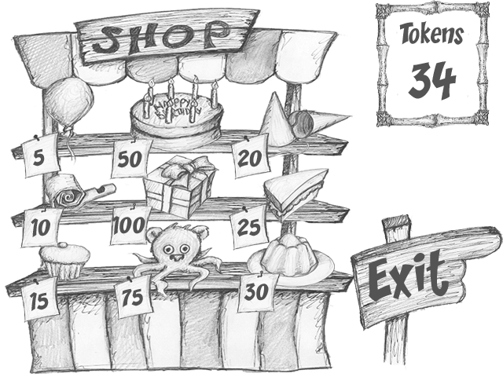

Some of the items can be bought more than once, however there is a limited stock, and once that stock runs out the item will be removed from the shelf.

Balloons | 5
Party Blowers | 3
Cup Cakes | 5
Birthday Cake | 1
Wrapped Present | 1
Soft Toy | 1
Party Hats | 3
Sandwiches | 3
Jelly | 1

A highlighting cursor flashes over the currently selected screen item. Moving a direction on the D-Pad will move this cursor in the appropriate direction. The cursor will also wrap around the screen if it moves too far in one direction. Clicking the action button on an item will add it to Sponge Bob’s Living Room and deduct the appropriate amount from the Token Counter.

When the player has finished they move the cursor over to the Exit Sign and press the action button – they will now be taken to Sponge Bob’s Living Room.

Sponge Bob’s Living Room

Sponge Bob is preparing his front room for a special birthday party for Patrick. Each item he purchases from the Kelp World shop will increase the amount of the happiness of Patrick.

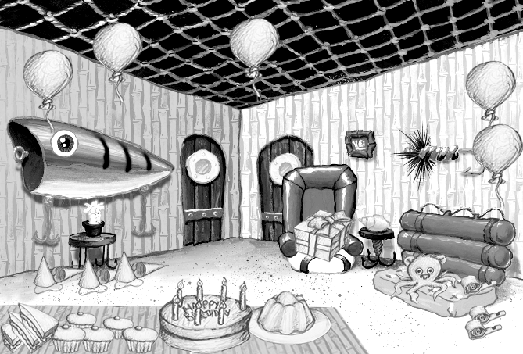

Each item is bought separately, and after each visit to the Shop, the player will see the items added to his party preparations.

When the player completes the final Boss they will first see the final FMA, and then visit Patrick’s Party to show him receiving all of his gifts (including the ultimate prize of the Signature).

When Patrick is particularly happy he will reveal a Cheat Code. The following token value of items need to be bought in order to receive a cheat code:

Wonky Mode | 50
Aussie Mode | 100
Super Speed Mode | 200
Cheeky Mode | 300
Super Hero Mode | 400
Buff Pants Mode | 465

The player will have to play the Kelp World levels and the final boss again and buy more items to receive another cheat code.

Losing Lives & Game Over

When the player loses a life they will be taken back to the last checkpoint they reached, or the start of the level if they have not yet reached a checkpoint. Once a player has used up all of their lives they will be taken to the Game Over screen and asked if they wish to continue. If they do they will restart the same level from the beginning with the default amount of lives. If they answer no then they will be taken back to the Start Screen.

Once back at the Start Screen the player is free to load a game from the last saved position or enter a password as normal.

Winning The Game

The game is won by completing all levels of the first 5 chapters. If this is achieved then the player will see the end FMA sequence, and will be given the cheat code for Buff Pants Mode. They are then returned to the Map Screen, enabling them to play for any Kelp Tickets they may not yet have acquired. A cheat code will be revealed each time they complete the game till all codes have been revealed.

Cheats

There are a number of cheat codes that the player can enter to unlock special features of the game. All of these are entered on the Credits Screen. They involve a combination of buttons and D-Pad directions. Only one cheat can be used at a time.

Cheat Name | Description | Sequence
Buff Pants Mode | Permanent Jelly Launcher & Infinite Ammo (except where another item is required to pass an area) | Action, Action, Action, Right, Action
Cheeky Mode | Low Gravity makes jumps higher | Up, Up, Up, Action, Jump
Super Speed Mode | Makes SB run twice as fast | Right, Right, Right, Action, Jump
Super Hero Mode | Infinite Lives | Down, Down, Action, Jump
Wonky Mode | Direction buttons are reversed | Up, Down, Left, Right, Jump, Jump
Aussie Mode | Flips the screen upside down | Down, Down, Down, Down, Action, Jump

An active cheat is acknowledged by displaying the appropriate message.

Cheat Codes are revealed by purchasing items from the Kelp World Shop, and making Patrick happy for his party. The better his party the more cheat codes he will reveal.

Game Controls

Overview

SpongeBob’s target audience is the 8-13 age group, and as such has controls that are as simple to use as possible. On both formats the controls follow an intuitive format in that one button is used to jump, one is used for every action and the D-Pad is used to control the character’s movement.

Movement
The D-Pad is used to perform the majority of SB’s moves.

- Left and right on the directional pad will move SB accordingly.

- Holding down on the D-pad will enable SB to duck, the camera will also pan down slightly to show the area below SB. When released the camera resets to it’s default position.

- Push up on the D-pad to look and pan above the player. When released the camera resets to it’s default position.

- Jump button. In conjunction with the D-pad SB can perform a directional jump. If the player presses and holds down the jump button he will perform a higher jump than if pressed & released quickly.

Actions
There are several actions that SB can perform:

- As well as ducking, pressing down on the D-Pad doubles up so that the player can soak up water in dry environments and still breathe.

- The up button is used to talk to NPC’s by pressing it within close proximity.

- Pressing the action button will use the current item in SB’s possession, however the use of each specific item is unique. When SB has no item in his possession the action button will perform a Karate Chop.

- Whilst in mid air SB can perform a Butt Bounce by pressing D-Pad Down.

Using Items

Each item is used in a slightly different way, however all are controlled via the action button (unless they are activated automatically on pick up).

Item | Usage
Ol’ Reliable | One press of the action button is required to capture a Jellyfish in the net. A second press of the action button will fire the Jellyfish in the direction of travel. The Jellyfish can also be fired straight up by pressing the up D-Pad with the action button.
Jellyfish Launcher | The Jellyfish Launcher has a limited amount of ammo, which SB must replenish by collecting Ammo Jars. Pressing the action button will fire a jellyfish in the direction of travel, though the direction can be changed by pressing a D-Pad button at the same time. The Launcher will fire in one of seven directions (all directions except down).
Coral Blower | Pressing and holding the action will suck button a nearby object into the blower. An aiming cursor will now appear on screen, the direction of which can be altered with the up and down D-Pad keys (within a 140° arc). Once the action button is released the object will be fired in the direction of the aiming cursor.
Bubble Wand | Pressing the action button will create a bubble directly in front of the player.
Balloon | SB can glide with the balloon in his possession. This is achieved by pressing the jump button to become airbourne, and pressing it and holding it again to enter glide mode. In glide mode SB can move around in a limited fashion. Letting go of the button will cause SB to drop, but he may enter glide mode at any time in flight.
Diving Helmet | Automatically activates. Pressing the action button will perform a Karate Chop.
Glasses | Automatically activates – can be used in conjunction with other power-ups.
Squeaky Boots | Automatically activates – can be used in conjunction with other power-ups. This item lasts for 6 seconds.
Super Hero Ring | Automatically activates – can be used in conjunction with other power-ups. This item lasts for 10 seconds.

Menus & Speech Bubbles

Before starting a game, or whilst a game is paused, the player will have to navigate a series of menus. These are simply lists of available options that can be scrolled through by pressing the up and down buttons on the D-Pad. A highlighted menu item is selected by one simple push of the action button.

During the game the player will be able to talk to NPC characters. This is achieved by the use of speech bubbles. The action button is used to forward to the next speech bubble, or pressing start will skip all of the current conversation.

PlayStation

The PlayStation controller also enables use of the left analogue stick, as well as the standard D-Pad for movement. The analogue control will allows for a slightly slower running speed when the stick is moved by a small amount otherwise it has a similar functionality to the D-Pad. Square is used to perform a jump, and X will perform any given action.

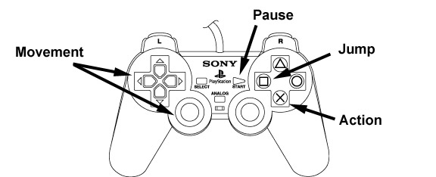

GAME BOY Advance

The GAME BOY uses the D-Pad for movement. The A button is used to make SpongeBob jump and the B button is used as the action button.

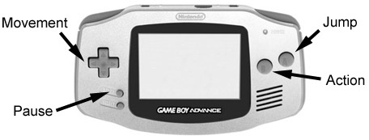

Control Summary

Function | Button
Move Left | D-Pad Left
Move Right | D-Pad Right
Duck | D-Pad Down
Soak Up Water | D-Pad Down over Puddle
Move Camera Down | D-Pad Down
Butt Bounce | D-Pad Down in Mid-Air
Move Cursor Down | D-Pad Down
Talk to NPC | D-Pad Up
Move Camera Up | D-Pad Up
Move Cursor Up | D-Pad Up
Fire Current Weapon | Action Button (+ Direction to Aim with Certain Weapons)
Use Special Item | Action Button
Karate Chop | Action Button
Jump Up | Jump Button
Jump Up High | Keep Jump Depressed
Jump Left | Jump + D-Pad Left
Jump Right | Jump + D-Pad Right
Pause Game / View Stats | Start

Game Information

Health Meter

The Health Meter overlay is situated permanently in the top right of the screen. It takes the form of Sponge Bob’s face. As he loses energy the overlay will flash and his expression will change to indicate his current status. SB has five points of energy available before he will lose a life. This energy can be topped up with the various health pick-ups scattered around the levels.

Water Meter
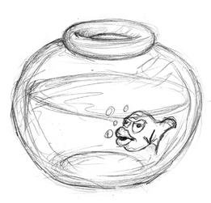
The Water Meter will slide into the top left corner of the screen when required i.e. when SpongeBob is out of water. It takes the form a Goldfish Bowl whose water slowly drains away. SB has around 8 seconds of water before he will start to lose energy at the rate of one unit per second. The meter will stay on screen as SB fills up in a puddle, but will disappear when he is fully re-submerged in water.

Ammo Counter

The Ammo Counter overlay is not permanently displayed on screen, but will slide into the bottom middle of the screen when needed.

Only two of the weapons require use of the ammo counter: the Jellyfish Launcher and the Bubble Wand. The ammo counter itself is dependant on the current weapon.

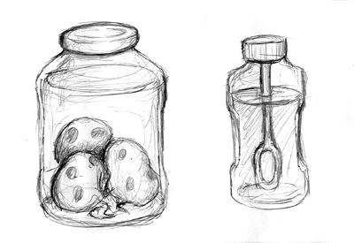
The Jellyfish Launcher counter is a Jam Jar filled with Jellyfish, and the Bubble Wand counter is a Bottle filled with Bubble Liquid. As the Jellyfish Launcher ammo is depleted a Jellyfish will be removed from the jar. Each time a bubble is used the liquid in the bottle will be reduced in volume. Once all ammo has been depleted the ammo counter will slide off screen.

Pause Menu

The game can be paused at any time, at which point the game world will dim in brightness and the game stats will be overlaid. At the top of the screen two icons represent the amount of lives a player has left and how many golden spatulas they have collected on the course of their travels.

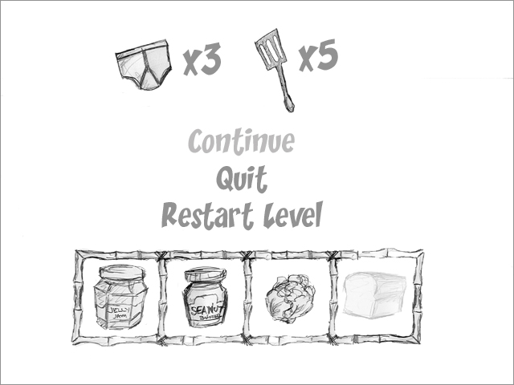

Underneath the icons is a menu that allows the player to: Continue, Quit or Restart Level. Although fairly self explanatory; Continue will resume the game from where the player paused it, Quit will exit the game and return to the main menu screen (after a confirmation to ensure they do not do this accidentally), and Restart Level will begin the current level again with the amount of lives they started the level with intact.

At the very bottom of the screen are the level objective boxes, which show the quest items SB has collected in the chapter so far. These will at first appear translucent until the item has been collected, when it will appear as a full colour icon.

Pickups

All pickups in the game float slightly above the ground, bobbing gently to distinguish them from their surroundings. Each pickup also has its own distinctive sound effect that is played briefly upon collection.

Pick Up | Sound Effect
Ol’ Reliable | Net Swoosh
Jellyfish Launcher | Splatting Jellyfish
Jellyfish Jam Jar Ammo | Jellyfish Splat
Coral Blower | Vacuum Suck
Bubble Wand | Bubble Pop
Diving Helmet | Darth Vadar Breathing Sound
Squeaky Boots | Squeaky Sound
Balloon | Squeaky Rubber Noise (Popping Noise on Dropping)
Disguise | Groucho Marx Noise
Golden Spatula | Cash Register ‘Ca-Ching’
Salty Fries | Small Mmm
Salty Shakes | Medium Mmmmm
Patty Burger | Big Mmmmmmmmmmm
Glasses | Michael Caine Voice
Super Hero Ring | *Change in Music for Duration*
Extra Life | Wahoo!
Quest Item | Fanfare

Power-up pickups will show up on SB’s person, except for the Super Hero Ring, which will cause SB to flash on and off for the duration of its effect. Every time a Health pickup is acquired the Health Meter will slide on screen briefly to show the new energy level. The Extra Life pickup will briefly display ‘Extra Life’ on screen on collection.

Speech bubbles

When SB meets a NPC he may speak to them in order to acquire new items and information. All speech is handled by a Speech Bubble, which will appear at the bottom of the screen with the character’s face in the corner. The player simply presses the action button to cycle through the speech bubbles, or start to skip the conversation all together.

